Group 6

Fan Jun, Jue Huang, Shiqi Liu

User Analysis and Requirement

**Preface**

This is the first version of the user analysis and requirement for the parking business owner. In this document you can find introduction, glossary, user requirement definition, system architecture, system requirement specification, system models and appendix of our smart parking application. According to this document, parking business owners can get more understanding of our smart parking application.

**1. Introduction**

Nowadays, labor is very expensive in the United States. Having staff to do all the jobs for the parking business is very inefficient and it is getting popular to let computers do the job for us. This application was created for this mission. This application can satisfy multiple needs for parking business owners. This application can accept walk in vehicles if there are available spaces, and it also can reserve parking space for hours that customers requested online. This application also can accept monthly membership to get them guaranteed space for the duration they requested. This application can update the occupied and empty space to calculate how many spaces are available. This application can alert the main office if a vehicle park in a wrong space. Users can add a temporary plate number that valid only one day and membership should have an official plate number. This application can keep tracking for the monthly revenue, parking usage, percentage of customer of members, online reservation and walk in.

**2. User Scenario/ user story**

* A driver who has an important meeting and he/she doesn’t want to waste his/her time on finding a parking area, so that he/she can use a credit card and plate number to make a parking reservation online in advance.
* A user can become a monthly member so that he/she is able to park the car anytime.
* Staffs need to check any available parking lot
* The manager is able to make rules (price, etc) so that he/she can see the calculated profit from the web for admin
* As an admin, I want to be able to define new parking spaces, so that the users have more selection for parking.
* If the user's meeting gets canceled and the user does not need reserved parking space anymore, he/she can cancel the reservation online before the reservation time, but after the reservation time, no refund will be given.

**3. Requirement:**

**System requirements specification:**

**3.1 Functional:**

* Web application for online parking reservation
  + Users need to log into the website by username and password.
  + Users can pay monthly membership to become a member
  + Member can register a plate number for making reservations
  + Users can find the closest parking lot and make a reservation by using credit card and plate number.
  + Users are able to view the details of the selected parking spot, such as the name, price, price and total available lots.
  + Users will receive the bill when they choose checkout
  + User are able to cancel the reservation online
  + Membership shall get guaranteed parking spot
  + Membership shall able to add a temporary plate for a day that gets automatically removed next day
* Web application for parking admin
  + Admin can track monthly revenue, parking usage
  + Admin can track the percentage of customers in each of the three categories (members, online reservation and walk in).
* Backend Management System
  + Define new parking areas, specify number of parking lots, and the parking cost per hour
  + Compute the available parking based online reservation and dive in parking. That means the application shall modify data of existing parking areas and view the data of all registered parking areas
  + System shall able to find a available parking area
  + Add, Delete,and Record the membership information
  + Check the customer parked spot. If it is a wrong spot, the system will communicate with the main office and provide the customer information. This customer will be asked to remove the car.

**3.2 Nonfunctional**

* System downtime shall not exceed 1 minute in any one day.
* The website shall be capable enough to handle 3 millions users with affecting its performance
* The website shall able to run on every browsers
* The website shall have a portable device version, and have no problem running on phone or tablet
* Users must verify by phone or email and reset their password after entering wrong password for 3 times

**4. System Architecture**

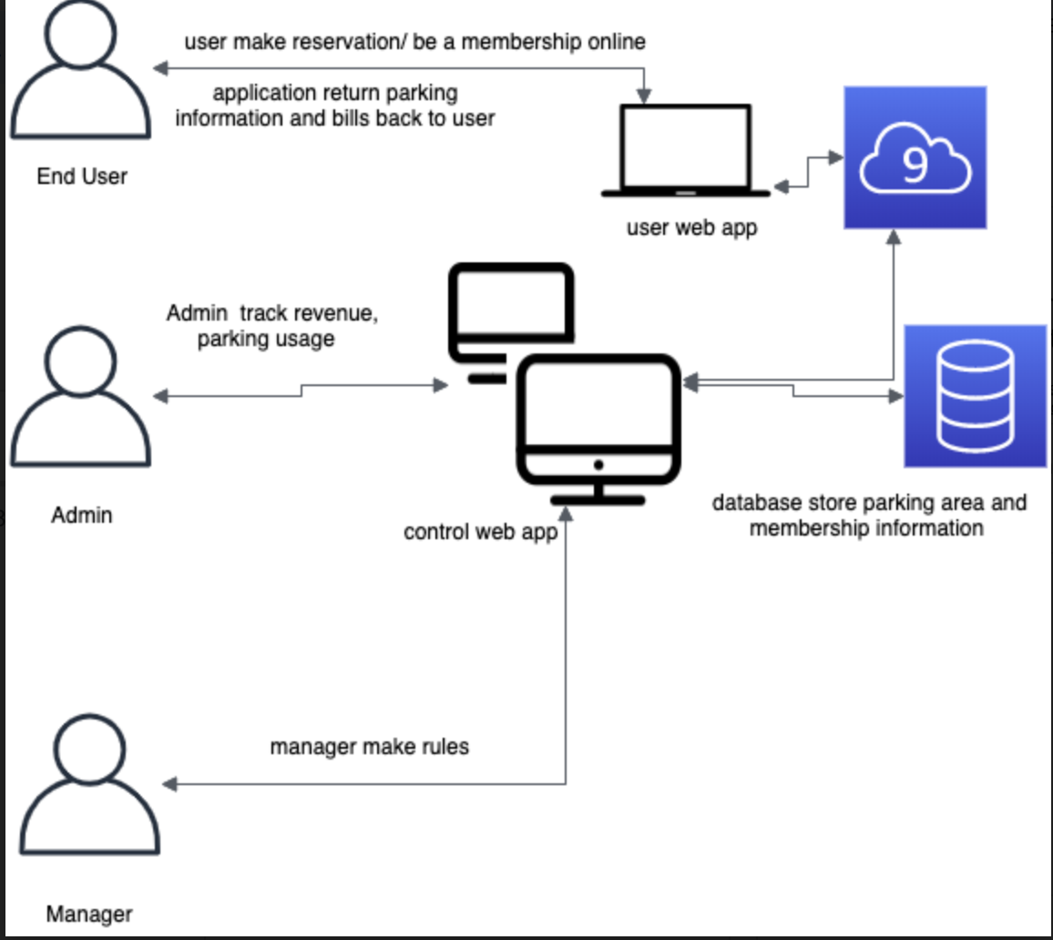

**5. Appendices**

* Hardware requirements: (define the minimal and optimal configurations for the system)
  + Web server
    - AWS
  + Database
    - MySQL
* Software requirement:
  + Database management
    - Remote desktop connection
* Database requirements: (define the logical organization of the data used by the system and the relationships between data)
  + Providing wide spread programming language support
  + Ability to manage multiple data structures and transparent data analysis capabilities across all those data structures
  + Data access, analysis and output

**6. Glossary**

* AWS: **Amazon Web Services** (AWS) is a secure cloud services platform, offering compute power, database storage, content delivery and other functionality to help businesses scale and grow
* Cloud Service: any service made available to users on demand via the Internet from a [cloud computing](https://www.webopedia.com/TERM/C/cloud_computing.html) provider's servers as opposed to being provided from a company's own [on-premises](https://www.webopedia.com/TERM/O/on-premises.html) servers. Cloud services are designed to provide easy, scalable access to applications, resources and services, and are fully managed by a [cloud](https://www.webopedia.com/TERM/C/cloud.html) services provider
* Database: a structured set of data held in a computer, especially one that is accessible in various ways
* MYSQL: an Oracle-backed open source relational database management system (RDBMS) based on Structured Query Language (SQL).